**Use PowerPoint to Create a Personal Seal**

ESL Level 5 @ MCC, Kristi Reyes, Instructor

**Step 1: Choose a design or background.**

##### **http://inpics.net/tutorials/powerpoint2007/graphics/custom20g1.gifOption 1: Employ design templates**

1. Click the **Design** tab.
2. In the Ribbon, click the **design that you prefer.**

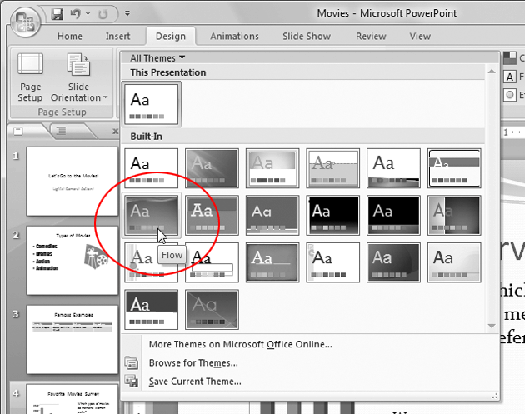

1. Click **Colors**.

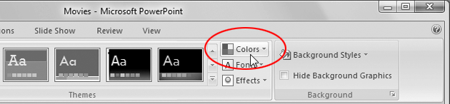

1. In the menu that appears, click the different options.

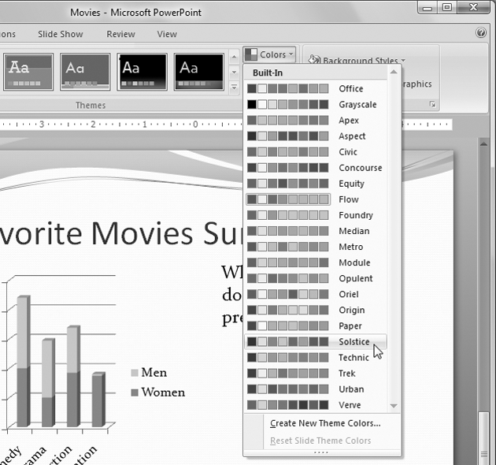

**Option 2: Apply a Gradient Background**

1. Click on the Design tab.
2. Click on the down arrow next to “Background Styles” in the top right.

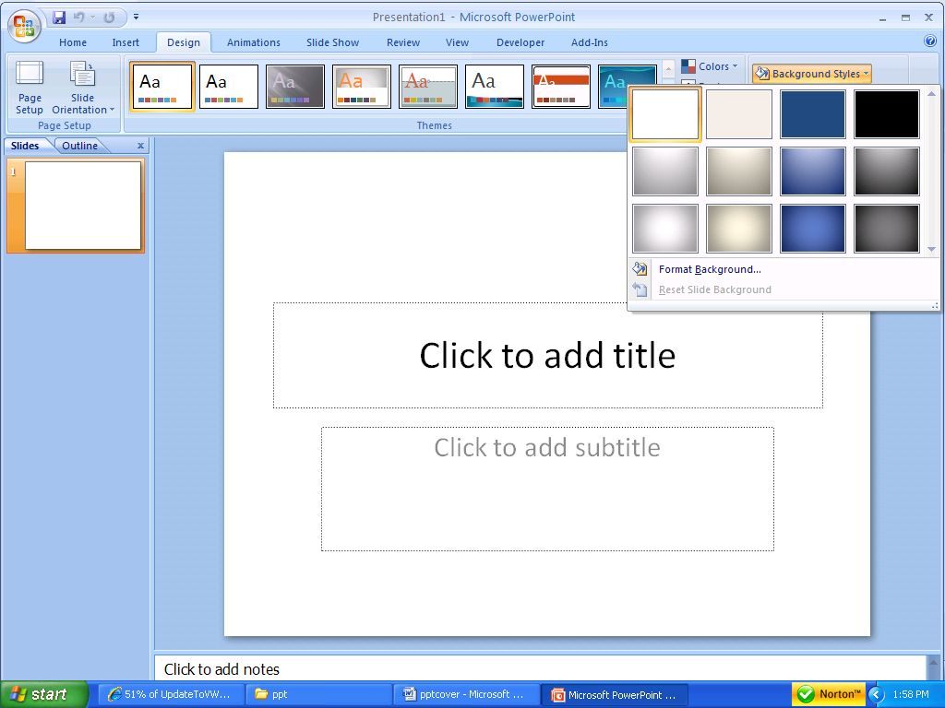

1. In the left pane, click on Fill.



1. In the right pane, click on Gradient fill.
2. To hide background graphics, click to select Hide background graphics.
3. To choose preset colors, click on the Preset colors button and choose the desired colors.

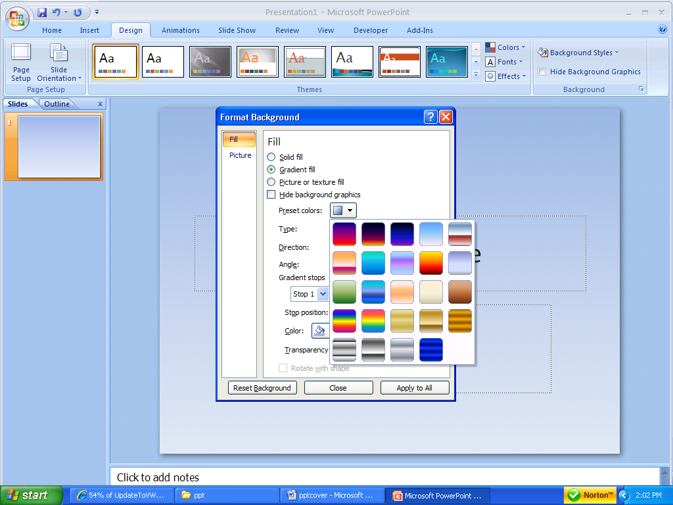

1. To change the type of gradient, click on the Type box down arrow and choose the desired type.

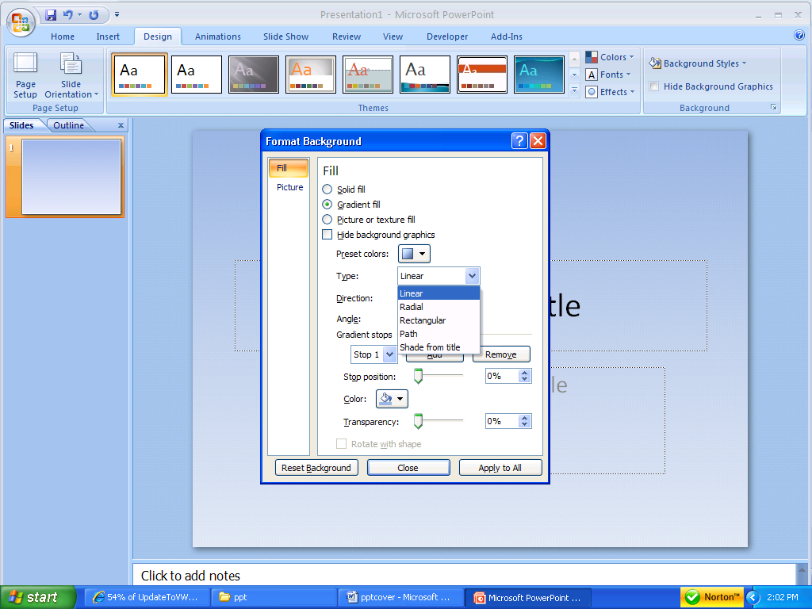

1. To change the direction of the gradient, click on the Direction button and choose the desired direction.

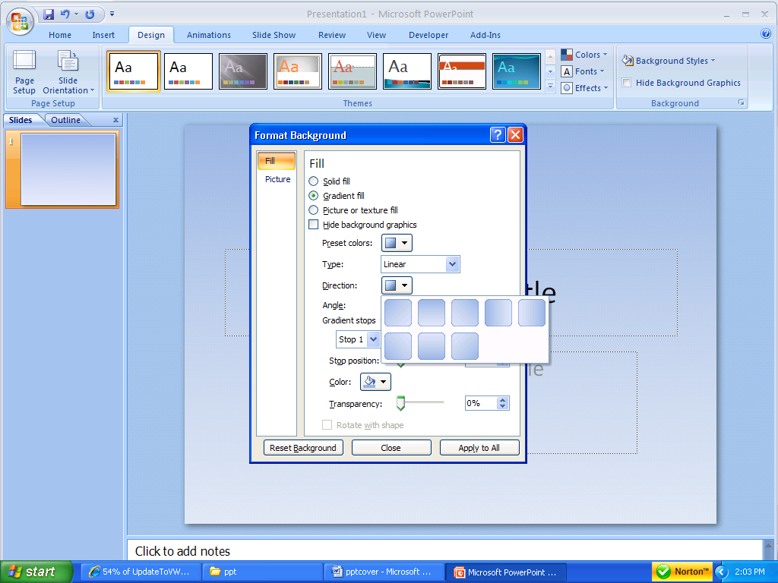

1. To change the color of the gradient, click on the Color button and choose the desired color.

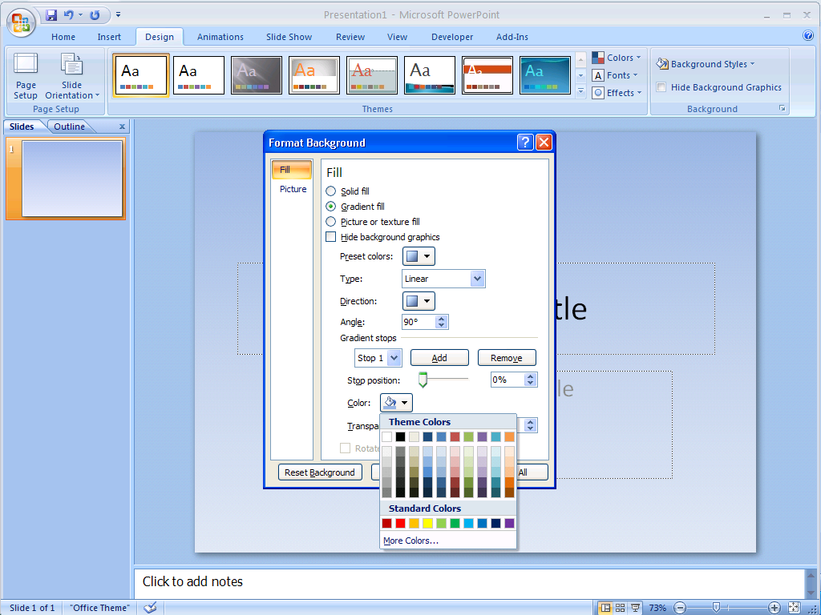

* To change the transparency of the color, click and drag the Transparency slider to the desired position.

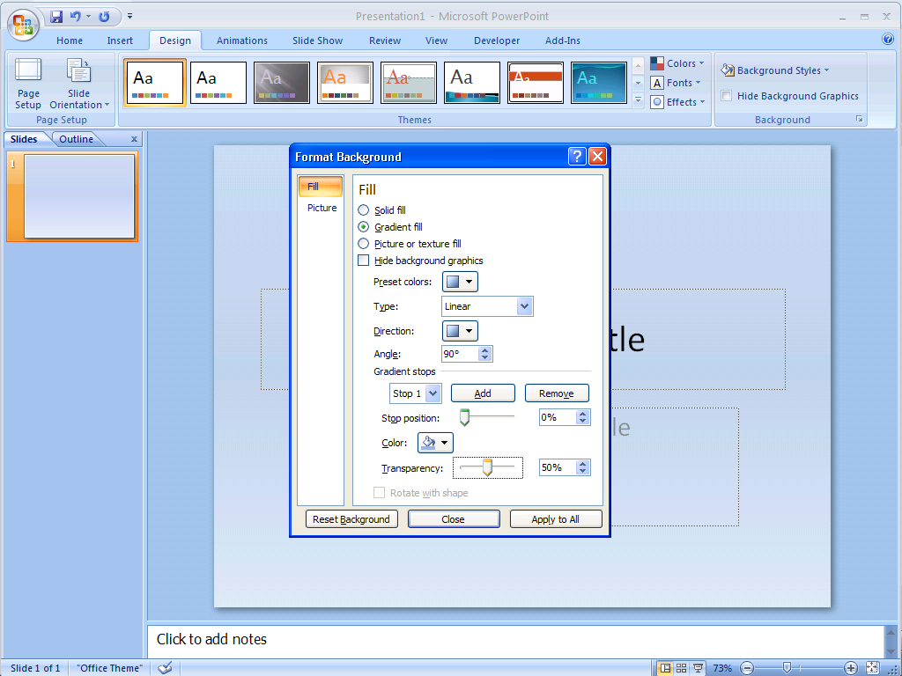

* Click on the Close button.

**Option 3: Apply a Textured Background**

1. Click on the Design tab.
2. Click on the down arrow next to “Background Styles” in the top right.



1. In the left pane, click on Fill.
2. Click in the “Picture or texture fill” circle.

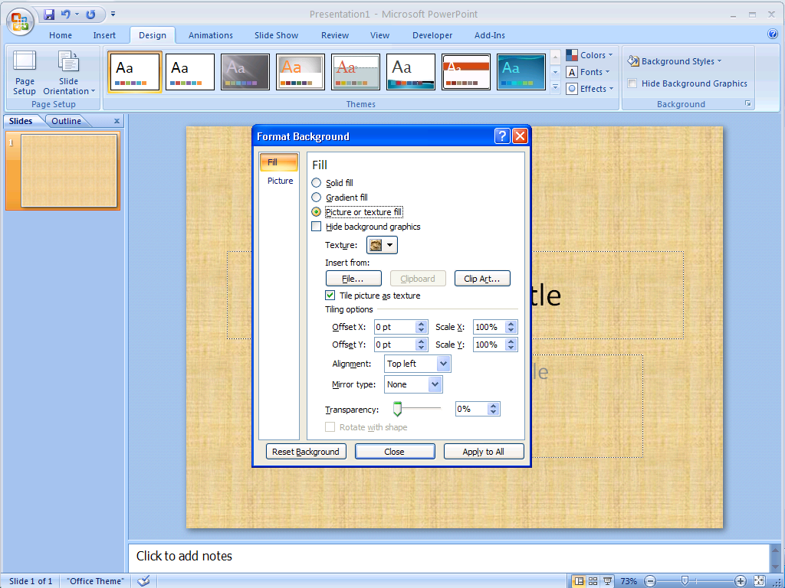

1. Click on the down arrow next to “Texture” to see options. Click on the texture you want to use.

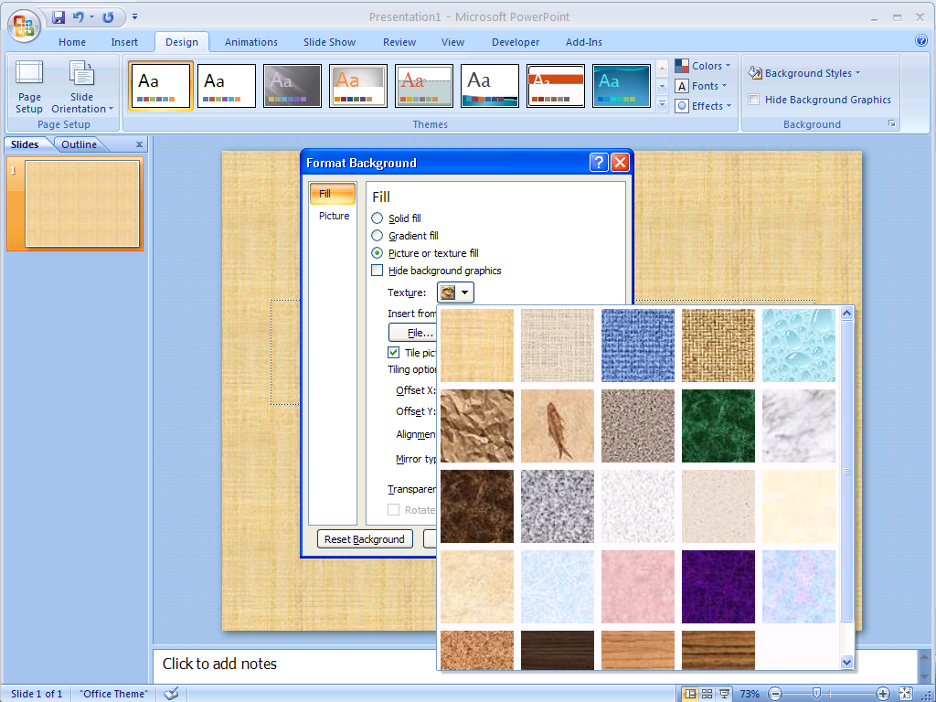

**Step 2: Insert and format images (pictures and clip art).**

|  |
| --- |
| **Option 1: Add a picture from clip art**       1. Click on the **Insert Tab**. 2. Click on **Clip Art**.      1. Find the **Clip Art** column. 2. Type the name of the image you want in the **Search For** box. 3. Click **Go.** 4. Scroll down to find the picture you want. 5. Click on the picture. 6. Follow the same rules for changing the size and moving the picture.  Option 2: Add images from the internet  1. Go to Google (images.google.com) or flickr.com or other site that has quality images online. 2. Type in a key word for type of image you want. 3. Click on **Search.** 4. Choose the picture you want by clicking on it to see it large. Right-click and choose **Save Picture As.**      1. Save the picture to the desktop. (Click Desktop and Save).     **To add a picture:**       1. Click on the **Insert Tab**. 2. Click on **Picture.** 3. Click on “Desktop” and click on the picture you want to insert.      1. Click Insert.   **How do I change the size of the picture?**   1. Click the center of the picture. 2. You see small boxes around the picture: 3. Put your mouse on any of the corner boxes. Move the mouse and you see a double arrow. You see this: 4. When you see the double arrow, hold down the left mouse button. 5. Move the mouse in towards the center of the picture to make it smaller. 6. Move the mouse out away from the center of the picture to make it bigger. 7. Lift up your finger.   **Option 3: Insert Shapes.**   1. On the **Ribbon**, click on the **Insert** tab. 2. Click on the **Shapes** button and choose the desired shape.      1. In the document, click and drag to create the shape in the desired location. 2. Make adjustments to the shape as desired.   **Note** – If the shape has yellow diamonds, these are used to change the proportions of the shape.  ***Adding Text to a Shape***   1. Right click on the shape and select **Edit Text**. 2. Enter the desired text.      1. Use the **Mini** toolbar to change the font, font size, font color, etc. 2. Click away from the shape.   **Ordering/Layering Objects**  Right click on the object and choose the desired option:    o **Bring to Front** ➔ **Bring to Front** puts the object on top of all other objects.  o **Bring to Front** ➔**Bring Forward** puts the object above another object    o **Send to Back** ➔ **Send to Back** puts the object behind all other objects.  o **Send to Back** ➔ **Send Backward** puts the object behind another object.    **Step 4: Add text (words), if desired**  **Option 1: Add Word Art**   1. On the **Ribbon,** click on the **Insert** tab. 2. In the **Text** group, click on the **WordArt** button  and choose the desired style of **WordArt**.      1. Type in the desired text. 2. To change the size of the box, click on the border of the box, move the cursor to a handle (box), then click and drag to the desired size (same as resizing a picture or clip art).     **Option 2: Add a Text Box**   1. Click the **Insert Tab.** 2. Find **Text.** 3. Click . 4. Choose a simple text box or scroll down for more options. 5. Click where you want to make the text box. 6. This is a text box: Text Box 7. Click in the text box. 8. Type in the box.   **Step 5: Save the slide as an image (.jpg).**  The instructror will demonstrate:   1. Click the Office button in the top left corner and click Save As. 2. Click on “Desktop” 3. In the file name box, type your name and personal sea, for example:  **kristipersonalseal** 4. In the “Save as type” box, click the small down arrow and choose “Jpeg.” 5. Click Save.   The instructor will show you how to add your personal seal to your wiki page. |